Pembroke Sports Sponsors
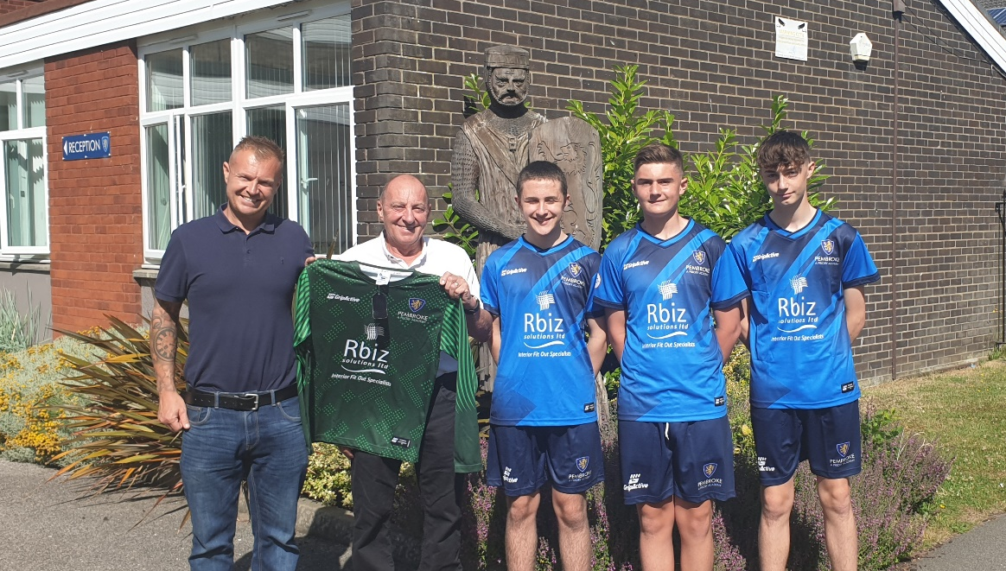


Rbiz solutions ltd Year 10 & 11 sponsors
A Lincoln based company, has been established since 2006 and has developed successful longstanding relationships with many companies completing shop fitting and interior fit out projects throughout the retail, commercial, leisure and public sectors nationwide
info@rbizsolutionsltd.com 01522 539772

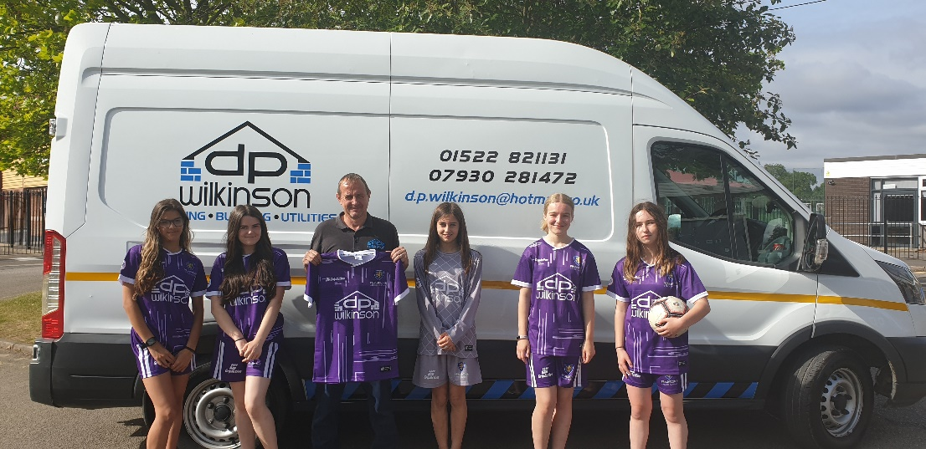

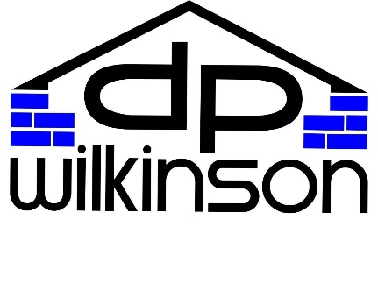
DP Wilkinson Year 7, 8 & 9 girls’ team sponsors
DP Wilkinson are a leading civils company in the construction sector, serving both domestic and commercial clients throughout Lincoln and the county of Lincolnshire with a variety of specialist construction and building services
info@dpwilkinson.co.uk 01522 514153

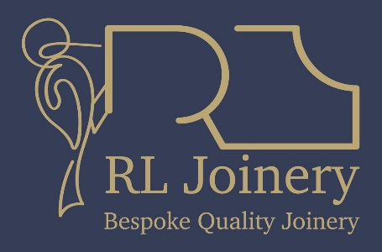
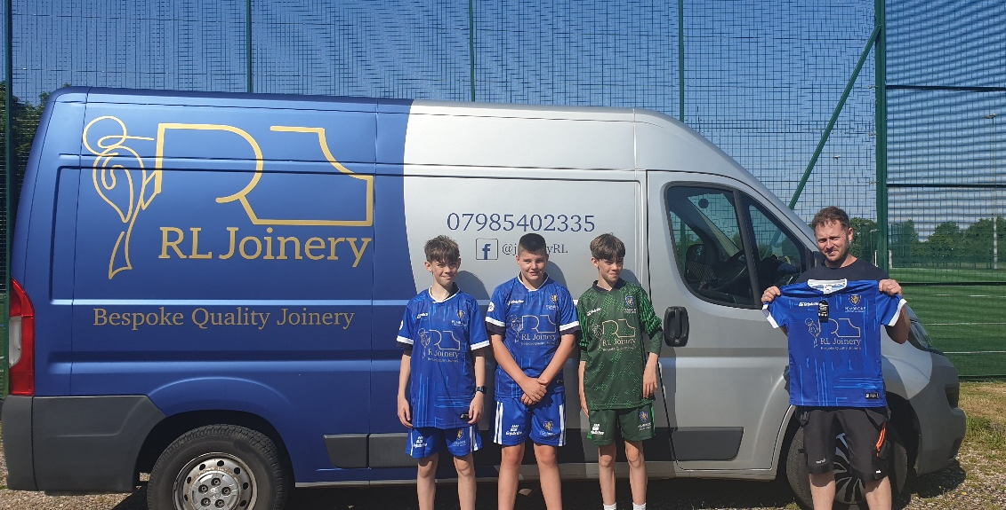

RL Joinery Year 7, 8 & 9 team sponsors
A Lincoln based joiner/carpenter with 20 years’ experience, with excellent customer service and quality joinery at affordable rates!
robertlenton@me.com 07985402335
Facebook – R L Joinery

