Summer Work
MyMaths Guidance
If you wish to continue to do some maths during the summer break MyMaths is available to use to do so.
There are a range of lesson, tasks, games and fun activities for you to choose from, and below is some guidance on how to navigate the website to find them.
- Go to mymaths.co.uk and select ‘log in’
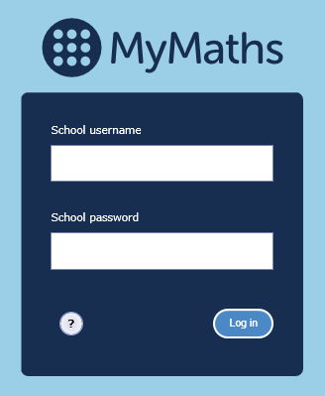
- Enter the school log in details
  - School username: ttpa
  - School password: circle

- Once in the website use the search bar to find a topic that you would like to work on
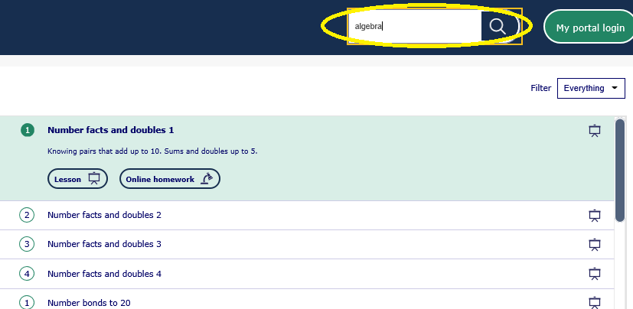
- Then choose from a game, lesson, revision activity or worksheet

